**The cleaning process involved before data analysis:**

Tool chosen for data cleaning and convenient warehousing : Excel

Illustrative snippet of uncleaned data

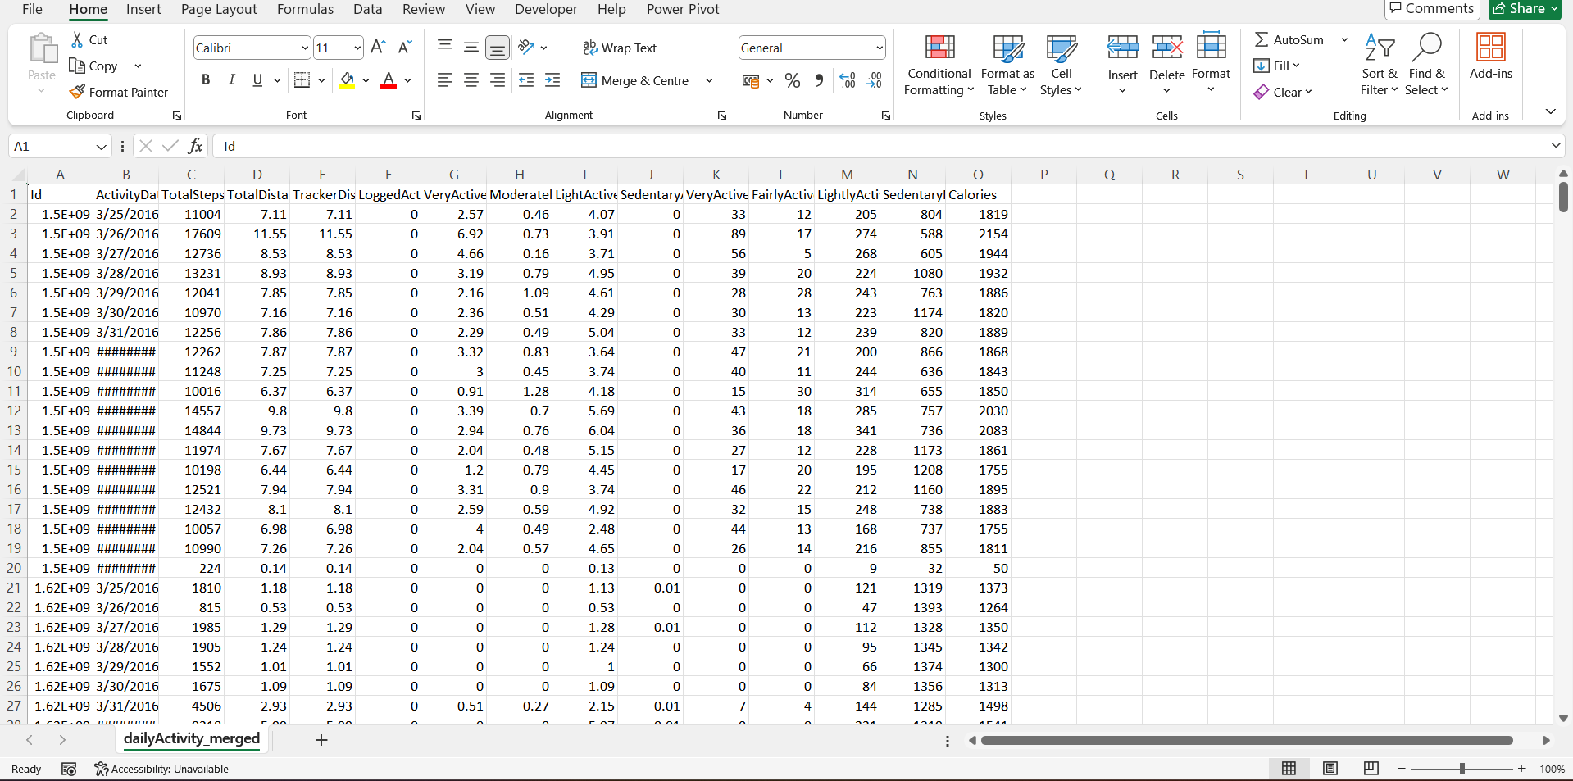

The cleaning process that was done to this worksheet for Data Analysis was:

1. Uniformly adjusting column width to make it look good.

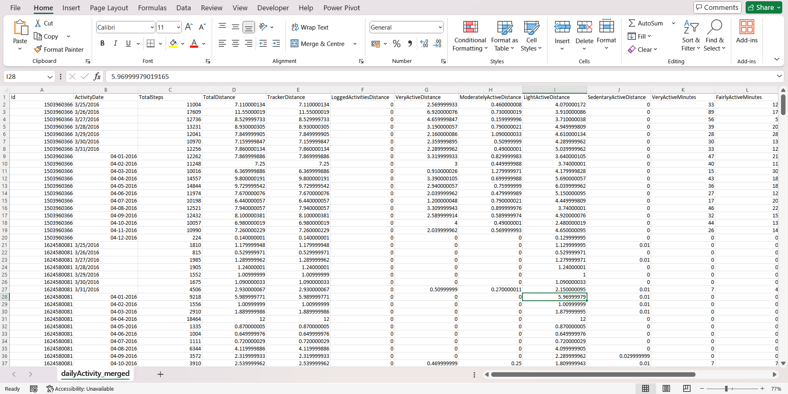

1. Aligning all the data to left side of cell.

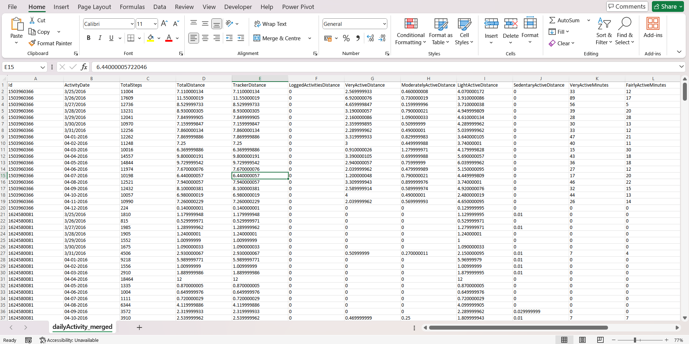

1. Standardizing data column and specifying data types for each column.
2. Highlighting Headers
3. Deleting Irrelevant columns and rows
4. Handling missing values
5. Handling duplicate values
6. Rounding values for columns having decimal values

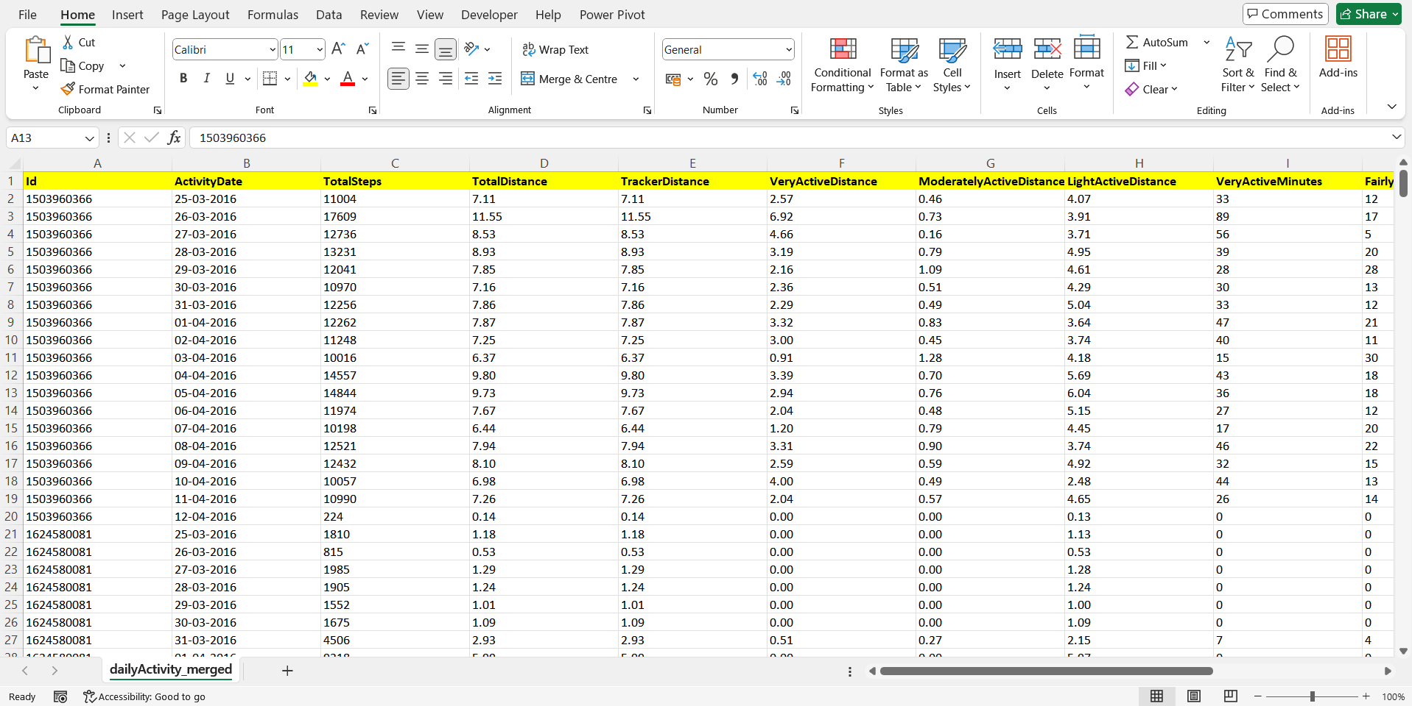

This is the final look of our excel sheet after data cleaning

Note: Similar operations were also performed on other dataset to prepare them for data analysis.